## System Design Document: E-commerce App

### 1. ****Introduction****

**1.1 Purpose:** To design and develop a robust e-commerce application that enables users to browse, select, and purchase products online.

**1.2 Scope:** This document outlines the high-level system design, including the system architecture, data flow, and key components.

### 2. ****System Architecture****

**2.1 High-Level Architecture:**

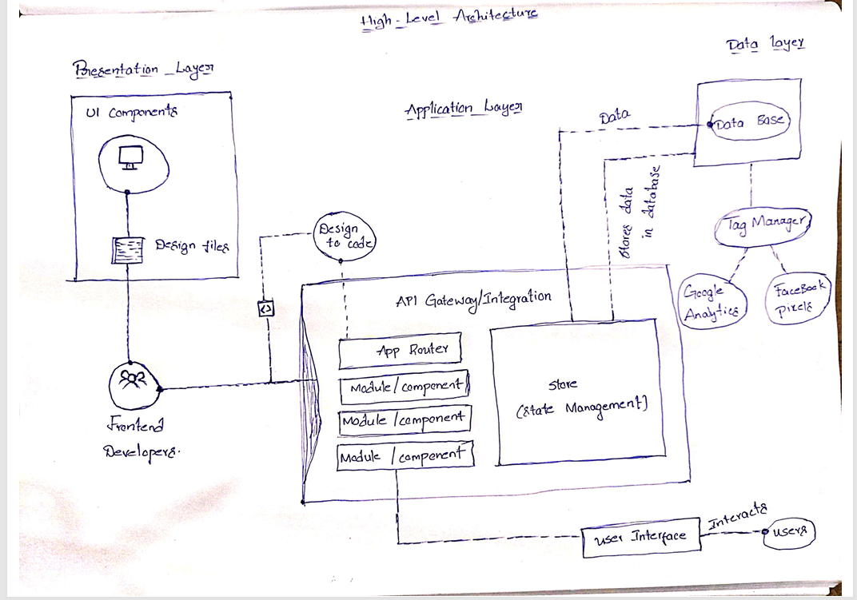

layered architecture diagram

* **Presentation Layer:**
  + User interface (web and mobile)
  + Handles user interactions and displays information
* **Business Logic Layer:**
  + Manages business rules and processes
  + Handles product catalog, shopping cart, and order processing
* **Data Access Layer:**
  + Interacts with the database
  + Retrieves and stores product, user, and order information

**2.2 Technology Stack:**

* **Frontend:** React, Angular, or Vue.js
* **Backend:** Node.js, Python (Django or Flask), or Ruby on Rails
* **Database:** MySQL, PostgreSQL, or MongoDB
* **Cloud Platform:** AWS, Azure, or GCP

### 3. ****Data Flow****

### 

### data flow diagram

1. **User Interaction:**
   * User browses product catalog.
   * User adds products to the shopping cart.
   * User proceeds to checkout.
2. **System Processing:**
   * **Product Catalog:** Fetches product information from the database.
   * **Shopping Cart:** Stores selected products and calculates the total price.
   * **Checkout:** Processes payment, generates order, and updates inventory.
3. **Data Storage:**
   * **Product Information:** Stores product details, images, and prices.
   * **User Information:** Stores user profiles and order history.
   * **Order Information:** Stores order details, payment information, and shipping address.

### 4. ****Key Components and Their Responsibilities****

* **User Interface:** Provides a user-friendly interface for browsing products, searching, and checkout.
* **Product Catalog:** Manages product information, including categories, descriptions, and pricing.
* **Shopping Cart:** Allows users to add, remove, and modify products in their cart.
* **Checkout:** Handles payment processing, order confirmation, and shipping information.
* **User Management:** Manages user accounts, profiles, and preferences.
* **Inventory Management:** Tracks product stock levels and updates inventory upon order fulfillment.
* **Order Management:** Processes orders, generates invoices, and handles returns and refunds.
* **Payment Gateway:** Integrates with payment gateways to process payments securely.

### 5. ****Security Considerations****

* **Data Encryption:** Encrypt sensitive data like credit card information.
* **Secure Authentication:** Implement strong authentication mechanisms.
* **Input Validation:** Validate user input to prevent malicious attacks.
* **Regular Security Audits:** Conduct regular security assessments.

### 6. ****Future Considerations****

* **Mobile App:** Develop a mobile app for iOS and Android.
* **Personalization:** Implement personalized product recommendations.
* **Loyalty Program:** Introduce a loyalty program to reward customers.
* **Social Integration:** Allow users to share products on social media.

By following this system design, we can build a scalable and user-friendly e-commerce application.

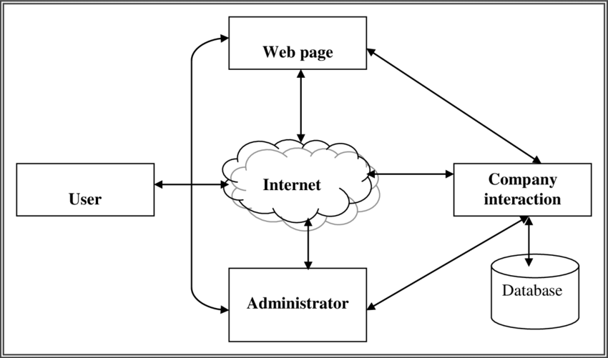

Google Network Ecommerce Diagram:

